A FIPA-OS BASED MULTI-AGENT ARCHITECTURE
FOR GLOBAL SUPPLY CHAIN APPLICATIONS

Mihaela Ulieru, Mircea Cobzaru and Douglas Norrie

Intelligent Systems Group
The University of Calgary, Alberta, Canada
http://isg.enme.ucalgary.ca

ABSTRACT

Based on our previously developed Multi-Resolution Collaborative Architecture (MRCA) [1] for global manufacturing applications we propose a novel solution to global supply chain management which implements MRCA using the latest standards of the Foundation for Intelligent Physical Agents (FIPA) [http://www.nortelnetworks.com/fipa-os]
Ways to implement the communication-cooperation layers and of the functional levels of MRCA are proposed by identifying suitable FIPA entities, and practical solutions for the implementation of global supply chain applications are given. Our vision for extending the FIPA-OS architectural elements to cover the development and implementation of generic web-Centric collaborative applications concludes the paper.

- INTRODUCTION
The recent advances in information technology have challenged dramatically the way enterprises do business by replacing the traditional off-line information processing methods with on-line real-time connections to the global economy. From e-commerce and marketing intelligence to custom-based product design and ordering, more and more transactions flow over the internet making distances between business partners measurable in “network intelligence power” rather than in thousands of miles. The increasing flexibility in choosing trading partners has opened ways to partnerships which were unthinkable before. Enterprises can constantly choose the best suppliers and customers can access the best deals in real time – keeping up with the fast paced environment of our current economy. Strategic partnerships are dynamically formed based on the latest information on “what’s out there” and virtual enterprises emerge from clusters of ‘best’ partners in the global supply chain. On-line inter-enterprise collaboration is the most powerful way to keep up and lead in today’s global economy.

In the past 10 years researchers of the Intelligent Manufacturing Systems Group at the University of Calgary have researched and developed multi-agent systems for manufacturing applications [1-5]. The essence of this research has been encapsulated into a versatile and generic recursive multi-resolution collaborative architecture (MRCA) that supports web-centric global manufacturing from the high level of inter-enterprise collaboration in the supply chain down to the low production control level [6], Fig. 1.
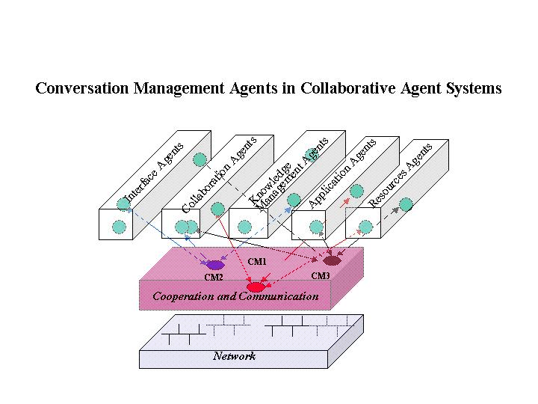

Fig. 1: MRCA: Communication-Collaboration Perspective

A detailed description of this architecture is presented in [6] – here we will focus only on the implementations details using the recent standards developed by the Foundation for Intelligent Physical Agents, namely the FIPA-OS standard [7].

- THE MAIN ARCHITECTURAL ELEMENTS OF THE FIPA-OS STANDARD
The FIPA-OS architecture provides an agent software framework and brings interoperability within and across agent based applications. It employs intelligent agents and the implementations are based on Java and Internet relevant technologies (XML, SMTP, Jini, Active Objects), elements which

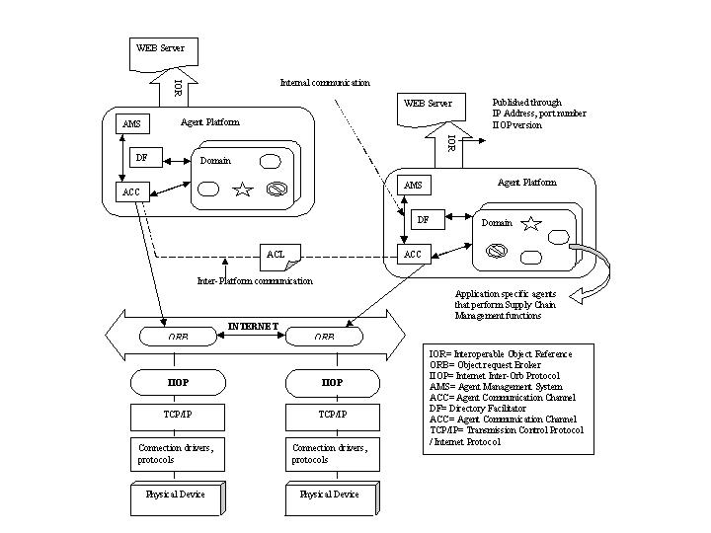
Fig. 2: The Main Elements of the FIPA-OS Architecture

have already become regular "ingredients" in applications of agents. The interoperability involves relationships between agents, between agents and platforms and relationships between implementations of agent services.
The FIPA OS architecture, Fig. 2, proposes the concept of Agent Platform (AP) which is built on top of a distributed computing environment, thus integrating the client/server paradigm with agent technology.
As it results from Fig. 2, the AP consists of three basic services: the Agent Management System (AMS), the Directory Facilitator (DF) and the Agent Communication Channel (ACC). When agents are registered with the AMS for a platform they are considered being part of that platform. The AMS is responsible for the management of operations on the agent platform as well as for the management of the agents themselves. The DF (an agent itself) works in a yellow pages manner and supports the localization of agents and the services they provide in the area of a domain or the whole environment. In order for the agents to be registered with a DF, they have to send a registration request to that service. The ACC uses information provided by AMS to enable agent communication between agents on a platform and between platforms by offering a message forwarding service. The high level of interoperability between platforms is made possible by placing a mandatory ACC agent on each agent system belonging to a FIPA compliant environment.
To support IIOP (Internet Inter-Orb Protocol), which is the necessary protocol for interoperability, the ACC agent is enabled with a CORBA interface. Thus, as a CORBA object, the ACC agent is provided with methods that can be invoked via IIOP. The communication between FIPA agents takes place through the specific communication language, FIPA-ACL.
The IORs (Interoperable Object References) must be distributed among the FIPA platforms so that interoperability can be achieved. Even though the IORs are not humanly readable, they are strings that can be transmitted in many ways: ftp, www, SMTP.
Different objects and/or programs can interact with one another through an ORB (Object Request Broker). Therefore, agents and applications, will each have their own "brokers", which can carry on the message exchange through the IIOP specifications, for that scope using the TCP/IP layer that provides the port numbers and hostnames for reliable delivery. In other words, the ORB layer is responsible for directing and "translating" the IIOP requests.
With current implementations of ORBs, it is not possible to use the URL as an address for a platform; hence, the solution to share a directory in which the platforms will have their own files containing the corresponding IORs.
The Domain, Fig. 2, is a virtual space (area) that facilitates the management of different application entities (supplier, order, search, transport, etc.) and encapsulates certain capabilities and restrictions for residing agents providing uniformity in the interactions that take place between software modules.
- IMPLEMENTATION OF MRCA FOR SUPPLY CHAIN APPLICATIONS USING THE FIPA-OS STANDARD
3.1. Generic Architectural Elements
The functional perspective on MRCA [6], Fig. 3, consists of an agent hierarchy (vertical) and a communication platform hierarchy (horizontal). The Communication-Cooperation layer in MRCA (Fig. 1) is implemented via several FIPA-OS Agent Platforms (Fig. 2) that support specific services as follows:
- Management and registration (AMS in Fig.2 – which implements the Messaging management level in MRCA, Fig. 3);
- Communication (ACC in Fig. 2 – which implements the Communication Services Management in Fig. 3);
- Agent Interaction (Domain in Fig. 2 – which implements the Conversation Management level in Fig. 3) – ensures uniformity in the interactions that take place between software modules;
- Yellow Page Services (DF in Fig. 2 – which implements the Collaboration Agents Level in Fig. 3);
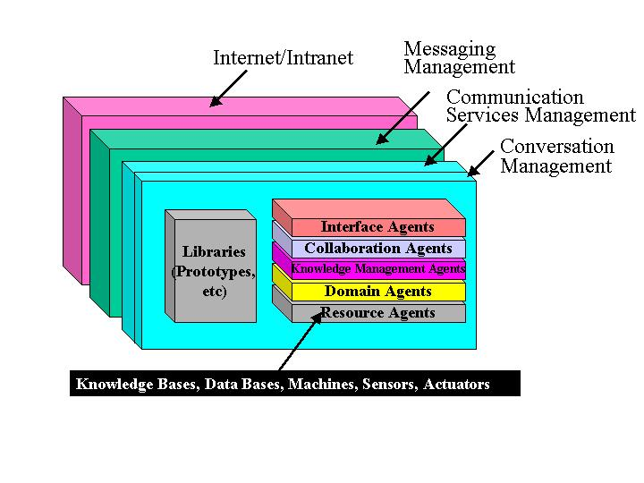
Fig. 3: MRCA – Functional perspective
Besides these generic architectural features, the implementation of global supply chain applications requires specific procedures and control elements. Supply-chain Application-Specific Agents, Fig. 2, implement the Domain Agents (i.e. roles such as inventory control, material flows, information storage, etc.) and the Resource Agents (i.e. capacity allocation, resource management, information management, etc.) in Fig. 3.

  - Specialized Agents for Supply Chain Management
The application specific agents (Domain and Resource Agents in MRCA, Fig. 3) needed in a supply chain implementation are presented in Fig. 4 as being served by information agents (Knowledge Management Agents in MRCA, Fig. 3).
The Information Agents (Fig. 2) are specific implementations of the Knowledge Management Agents (Fig. 1,3), meant to manage the flow of information between the various Resource and Domain Agents. Their ability for flexible interaction and interoperation with the other software agents makes them emerge into an infrastructure, an information "inter-space" where information is stored, maintained, converted and shared among specialized agents.

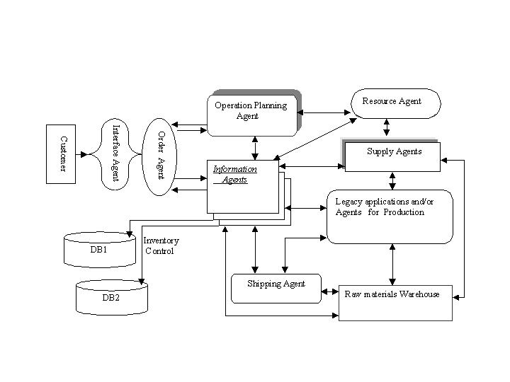

Fig. 4: Supply-Chain Application Specific Agents and their
Interactions

Information agents also carry out communications with functional agents mediating message exchanges among them, routing and distributing at the same time the required information in the right form to those that need it. The specialized agents that perform supply chain functions can store information and knowledge locally and access information and knowledge throughout the network using the services mediated by Information Agents.

The Supply-Chain Application Domain Agents are:
- Shipping Agents are responsible for the allocation and scheduling of transportation resources required by the operation planning agents. Among their data we can find different transportation routes, schedules and the associated costs;
- Order Agents are responsible for handling requests from customers, approving orders and getting information regarding the orders. This information is then passed to the operation planning agents.
- Operation Planning Agents detail customer orders fulfillment and handle the distribution of materials and products across the supply chain network.
- Legacy applications and Production Agents are responsible for operations involving planning, scheduling and manufacturing of products based on demands.
- The Resource Agents are production specific agents that evaluate the network capacity by comparing the capabilities with the order requirements and send feedback to the Operation Planning Agents regarding possible schedules. They manage the availability of resources related to suppliers, production and transport to maximize efficiency so that a certain schedule can be accomplished. The Databases contain information about inventory- products that are already in stock which have been built based on demand forecast, or parts and materials sorted by name, cost and quantity required to manufacture a certain product.

3.3 FIPA-OS Based MRCA for

Global Supply Chain Management
The implementation of the generic Multi-Resolution Collaborative Architecture (Fig.1, Fig. 3) using FIPA-OS architectural standards (Fig. 2) is presented in Fig. 5. The Protocol and Communication Layer in Fig. 5 implements the Communication-Collaboration Layer of MRCA (Fig. 1) using FIPA specific standards, as described in Section 2 (Fig. 2). The SCM Specialized Agents are built using a template and then ‘plugged’ into the Agent Layer as Resource or as Application Domain Agents. The Platform Agents manage the local inter-agent communication as well as the inter-platform communication over the distributed application. The architecture in Fig. 5 supports customer-centric global supply chain applications capable to fulfill any order on-line while optimizing the costs and delivery time by taking full advantage of the enabling internetworking technologies. Once an order for a specific product has been placed by a customer, the inter-agent communication-cooperation for order fulfillment (Fig. 4) goes as follows. The Order Agent contacts the Information Agent who has knowledge about the product’s design mapped into a database of potential collaborators on the production and/or delivery of the different parts and/or materials. According to the priorities, the collaborators will be each contacted via the inter-platform communication supported by the ACC/FIPA-ACL mechanism and the ones who commit to deliver in the shortest time are selected. For each partner an Agent Platform is in place, as in Fig. 2. The detailed description of the inter-agent collaboration on a case study involving a multi-national corporation is presented in [6]. Here we only focus on the FIPA-OS mechanisms that facilitate its implementation. The selected partners for the parts and/or materials will register with the main manufacturer and proceed to plan their individual jobs using the Operation Planning Agents that will dispatch the operations on each resource involved in production. The control mechanism for production control at the factory level is detailed in [6].
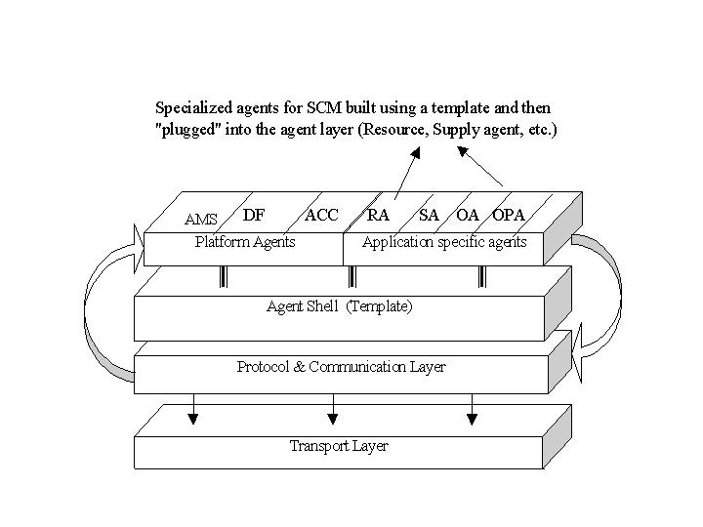

Fig. 5: Supply-Chain Specific MRCA Implementation
according to FIPA-OS Standards

For each partner involved in the collaborative application the Supply Agents will provide that all the necessary materials and supplies for the specific order are available in due time. The Shipping Agents will manage delivery in due time to the main manufacturer of all the parts, once they are ready. Here the final product is assembled and delivered (via its Domain specific Shipping Agents) to the customer.

- FIPA-OS AS AN ENABLING
TECHNOLOGY FOR GLOBAL INTER-
ENTERPRISE COLLABORATION
The mechanisms that facilitate global supply chain management can be extended to any kind of global inter-enterprise collaborative application requiring web-Centric e-Business concepts. Using optimization methods to cluster the most appropriate partners for a specific collaboration we have developed emergent organizations mechanisms capable of rapid response to the ever-changing demands of a fast-paced economy [8] [9]. These mechanisms play an important role in the implementation of global organizations which base the essence of their existence on information exchange between several organizational entities distributed at various locations around the globe. The combination of Multi-Agent technologies with the web-Centric paradigm opens wide perspectives towards the development of mechanisms for creation of virtual organizations with a flexible, self-organizing structure. Unfortunately the current FIPA specifications do not currently address the implementation of web-Centric paradigm specific elements. However FIPA-OS can be easily extended to cover the e-Business aspects by building agents to take over order-taking, accounting and security tasks. Moreover, software agents can collect information on products and suppliers that could fulfill the orders, evaluate biddings, making decisions on them, negotiating terms of transactions, place orders and make payments to the parts involved in the supply chain network. To integrate all these technologies seamlessly there is a need to define universal standards for goods and services, consumer and vendor profiles, nature of services, secure payment mechanisms, and business electronic forms. A set of issues such as security, performance, failure may be handled by proper design, others like communication and interoperability between applications may be managed through the use of so-called middleware solutions (CORBA, DCOM), additional software platforms (Voyager) or built-in language mechanisms (Java RMI) and Web specific metalanguages (XML). There is also a trend in this area of integrating pre-built objects (available in thousands on the Internet) and reusable software parts (component-based software)
with built-in interfaces that allow features such as interoperability to be included in intelligent systems and applications. The participating agents will cope with the requirements of the roles they play if they have access to information stored on the Internet, are able to accept queries from users and make pertinent decisions. Thus, switching from plain HTML to the relatively new metalanguage referred to as eXtensible Markup Language (XML), seems just the right means to exchange and manipulate encapsulated data in Internet applications. At the same time, XML together with Java based technologies may be used to code the business rules of agents and service interaction in order to share common, ethical goals.

5. CONCLUSIONS
The proposed FIPA-OS based supply chain architecture is easily adaptable since changes occurred in the configuration of the supply chain, or in the production within the supply chain, can be managed by adding new entities into the system or enhancing the existing ones. The potential of agent technologies and the use of FIPA ACL as a communication approach based on commitment can be exploited to build layers of intelligent interaction and knowledge-sharing. Such mechanisms open enormous potential towards the design of self-organizing, re-configurable architectures needed in a dynamic environment such as web-Centric global supply chain management

REFERENCES
[1] Maturana F., Shen W., Norrie, D. H., “MetaMorph: An Adaptive Agent-Based
Architecture for Intelligent Manufacturing”, International Journal of Production Research, 37(10):2159-2174, 1999.
[2] Ulieru, M., Norrie, D., “A Multi-Agent System for Supply Chain Management”, Progress In Simulation, Modelling, Analysis and Synthesis of Modern Electrical and Electronic Devices and Systems (N. Mastorakis, Ed.), World Scientific and Engineering Society Press, pp. 342-348, 1999.
[3] Gu, P., Balasubramanian, S. and Norrie, D.H., 1997, "Bidding-Based Process Planning and Scheduling in a Multi-Agent System" Computer and Industrial Engineering, Vol. 32, No. 2, pp. 477-496.

[4] Ulieru, M., Norrie, D., “A Multi-Agent System for On-Line Fault Recovery of Intelligent Manufacturing Systems”, Proc. NAFIPS’99, pp. 849-854, NY,USA, 1999.
[5] Shen, W., Ulieru, M., Norrie, D.H. and Kremer, R., "Implementing the Internet Enabled Supply Chain through a Collaborative Agent System", Agents’99 Workshop on Agent Based Management of the Internet-Enabled Supply-Chain, Seattle, WA, pp. 55-62, May 1-5, 1999.
[6] Ulieru, M., Norrie, D., Kremer, R. and Shen, W. (2000), A Multi-Resolution Collaborative Architecture for web-Centric Global Manufacturing, Information Sciences 127, pp. 3-21.
[7] FIPA-OS specifications and documentation at http://www.fipa.org/ & http://www.nortelnetworks.com/fipa-os/
[8] Ulieru, M. and Norrie, D. (2000) Fault Recovery in Distributed Manufacturing Systems by Emergent Holonic Re-Configuration: A Fuzzy Multi-Agent Modeling Approach”, Information Sciences, 127, pp. 101-123.
[9] Ionita, S. and Ulieru, M. (2001) Emergence of Holonic Virtual Organizations from Multi-Agent Systems: A Fractal Theoretic Approach, submitted to Autonomous Agents 2001, Montreal, Canada.

