Enrique M. Tognalli¹, MSc., Member, IEEE, Mihaela Ulieru², PhD., Senior Member, IEEE

¹Electrical Engineering, University of Calgary, Calgary, Canada, e-mail: emtognal@ucalgary.ca
² Canada Research Chair, The University of New Brunswick, Canada, e-mail: ulieru@ucalgary.ca
Pervasive Information Infrastructures for Industrial Informatics
- An Application to Emergency Response Management -
Abstract—This work proves the technical feasibility of creating pervasive computing infrastructures using multi-agent systems which interact with heterogeneous non-agent systems. Our main contribution is the development of a pervasive environment which enhances the interaction between heterogeneous systems by using standardized protocols for communications between software agents bridging the non-agent systems within the pervasive framework. Using the proposed framework developers will focus only on solving the problem without having to worry about integration, deployment, data formatting and communication between the different modules of their applications. Users will have access to all the relevant application data without having to switch between applications from different developers - the framework provides them with an application capable of accessing any piece of information within the domain.
In this work, the framework is used to deploy an emergency response application. This does not prevent using it in any other domain.

Index Terms—Pervasive information environments, multi-agent systems, hybrid systems, emergency response management.

INTRODUCTION

1.1. Pervasive Computing
Developing a distributed wireless application able to run over different hardware platforms, incompatible operating systems and accessing data encoded in proprietary formats is a very difficult task. Ubiquitous computing, also called ‘pervasive computing’, is the new wave of computers in the world. This term describes a user surrounded by so many devices that he/she almost does not realize their existence. However trying to integrate such a quantity of devices from different vendors and implement it using a wide selection of technologies is difficult. Middleware capable of enabling information exchange must exist between such devices in order to take Weiser’s [1] vision one step closer to realization.
Pervasive computing defines a major evolutionary step in software systems, Fig. 1; this evolution began when the PC first brought computers closer to people, and it continues today. As computers became connected, they began to share capabilities over the network. Distributed systems marked the next step toward pervasive computing by introducing seamless access to remote information resources and communication (protocol layering, remote procedure calls [2] and timeouts) with fault tolerance (atomic transactions and two-phase commit), high availability (24 by 7 service), and security [3].
Distributed System
Mobility Support
+
Mobile System
Pervasiveness
Support
+
Pervasive System
Figure 1: Evolution of Pervasive Systems

The World Wide Web is an attractive choice today for experimenting with distributed systems concepts. Its ubiquity is a starting point towards pervasive computing; nowadays most people check their e-mail or homepages without realizing the actual use of a computer. The next step in the evolution of software systems is ‘mobile systems’. They emerged from the integration between cellular technology and the World Wide Web [4]. Both the size and price of mobile devices are falling everyday and could eventually support Weiser’s vision of pervasive inch-scale computing devices readily available to users in any human environment. Currently, more and more cell phones’ companies develop their devices with the capability of executing user-downloaded software; this allows developers to create applications with the potential of being executed anywhere anytime.
Mobile Systems provide new characteristics that were not present in distributed systems; they are grouped into 4 broad areas [3]: Mobile networking - Mobile information access including disconnected operation - Energy-aware systems [1][5] - Location sensitivity
The “anytime anywhere” goal of mobile computing is essentially a reactive approach to information access, but it prepares the way for pervasive computing proactive “all the time everywhere” goal. There are four main attributes of pervasive applications [3]: Effective use of Smart Spaces - Invisibility [1] - Localized Scalability – Masking uneven Conditions.
Pervasive environments are being created at an increased rate of activity over the last years. Developing applications and systems that take advantage of such environments is not a simple task. Some examples of such systems are [16][17]:
• Aura: (www-2.cs.cmu.edu/~aura) Aura's goal is to provide each user with an invisible halo of computing and information services that persists regardless of location.
• Endeavour: (endeavour.cs.berkeley.edu) a prototype implementation of planet-scale, self-organizing, and adaptive “information utility”.
• Oxygen: (www.oxygen.lcs.mit.edu) Enables pervasive, human-centred computing through a combination of specific user and system technologies.

1.2. Multi-Agent Systems
There is no globally-accepted definition of ‘software agents’ in the field of software engineering. Software agents are now becoming the focus of commercial applications although they have been around in research environments. In the recent past, the term ‘agent’ has been widely used to refer to any software system which has attributes of intelligence, autonomy, perception or acting on behalf of a user. In general, an agent is a piece of software, possibly with some intelligence, with a well-defined role and a set of goals; it can even be autonomous (acts independently) and pro-active (or perceptive) [6], [7].

1.3. Motivation
The possibilities of human-machine interaction are growing day by day. The goal of taking advantage of such interaction is to improve people’s quality of life. For example, the idea of sensors getting information in real time about our health, mood, and location and being able to act upon those records in order to improve our everyday experience is overwhelming and an excellent goal to aim for. In an emergency systems domain, we can imagine a patient under home care with sensors inside the house and embedded inside his body sending his vital signs trough a wireless network for remote monitoring; or even mobilizing ambulances towards the patient’s house because the application detected changes that may put the person’s life in danger.
The main motivation for this work is to put together a multi-agent system capable of running on a wireless network using pervasive devices that will give the application a sense of location awareness in order to make decisions based on geographical proximity. This application will prove that building a more complex system to solve more complex requirements is feasible from a technical perspective. The multi-agent system will not only help to overcome communication problems but will also make decisions based on the proximity of the user to the desired entities.

Pervasive Emergency Response Environment

2.1. Proposed Solution
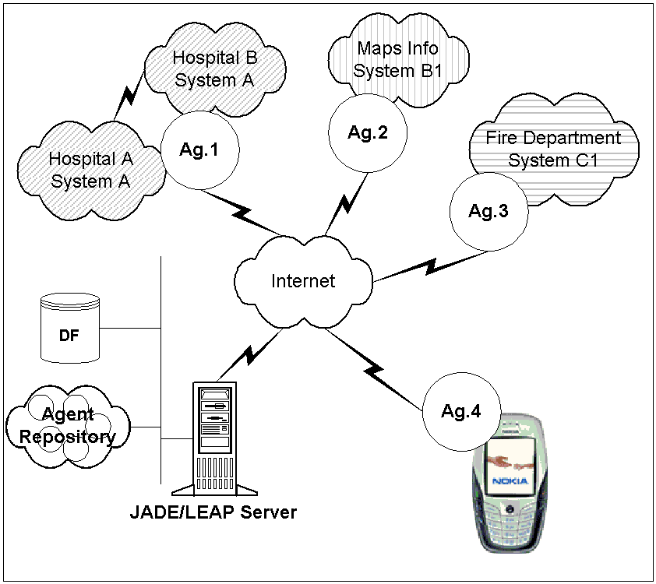
When trying to access information produced by different sources, integration becomes a common problem. In an emergency situation, for example, this causes delays because a human operator is needed in order to interface the different systems, get the information and send it back to the user requesting the vital data in the field. In the proposed emergency management system, a multi-agent system that handles the communication between all systems is used.
Figure 2: Proposed Solution
We used the multi-agent platform JADE [8] / LEAP [9] which allows the system to interact with other FIPA [10] compliant platforms seamlessly, and as such solve the interoperability issues.
The proposed outcome is shown in Fig. 2. The agents act as bridges between proprietary systems and the standardized system such as FIPA-based ones. In Fig. 2 Ag.1, Ag. 2 and Ag. 3 are developed by the vendors that are interested to interoperate with all the other systems. These agents register their services with the general directory facilitator (DF); by doing so they record what information they produce, how to request that information and what tasks they can perform. Ag.4 is the application that is being developed in this work and was very difficult to do in the first scenario. In the new scenario the following tasks must be performed: create an agent that can search the DF, contact the other agents and request the information, and receive the information. Moreover, because JADE-LEAP agents are implemented using J2ME (Java 2 Micro Edition) [11] they can be executed in Java-compliant cell-phones [12][13] and devices [14]. In this scenario each vendor develops an interface using agents between their systems and the JADE-LEAP platform. They are able to restrict the information that the outside world accesses in the system. This allows them to still have a secure system and be in control of the information contained inside.
The messages between the agents were encoded using an emergency domain ontology developed for this application using Protégé (http://protege.stanford.edu/). Figure 3 shows the taxonomy tree that represents the ontology once implemented in Protégé, and also a partial screenshot displaying the properties of the ‘Ambulance’ class.
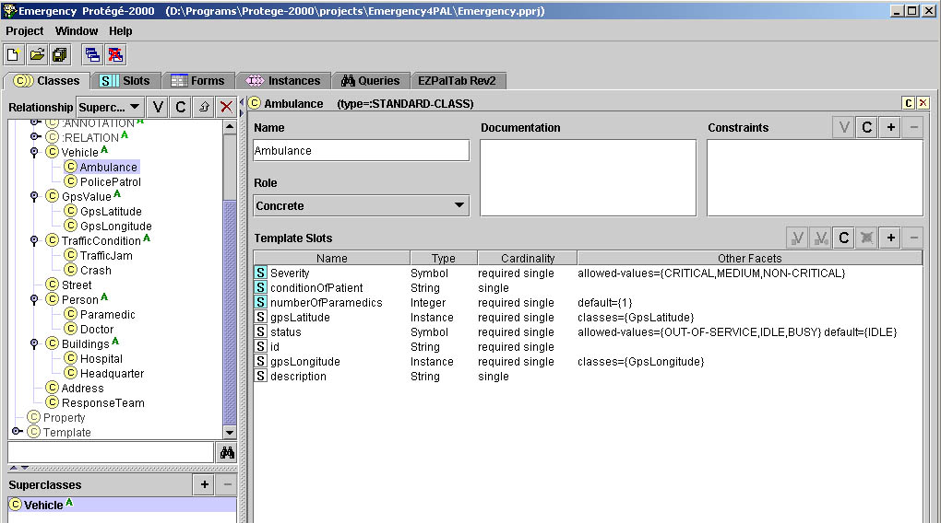
Figure 3: Taxonomy Tree - Ambulance Class
The inheritance relationships are shown in the taxonomy tree while the use relationships are represented as properties of the class. The use relationship between this class and the GpsLatitude and GpsLongitude classes are represented in the Type of the property. The gpsLatitude and gpsLongitude slots (or attributes) of the class are “instances” of the previously mentioned classes. Another specific type of slot is “Symbol”, which restricts the possible values that can be entered in one particular slot. In this example the slot status can only be one of the following values: OUT-OF-SERVICE, IDLE or BUSY. These are constraints that can be entered while developing the ontology, and the tool enforces them when data is being entered.
The main objective of this ontology is to provide enough information to fill the ResponseTeam class (Fig. 3) according to the type of emergency so that the response team can manage the situation in the best possible way.
For further details about ontologies please read [15].

2.2 Use Cases
In this section a subset of the specific use cases for the developed application are presented. In this application the agents that handle the searching and booking of a specialist inside all Hospitals that are registered in the DF of the system are created. The Ontology for handling the information exchange for these actions and the Hospitals agents that will reply to the inquiries from the other agents is also created.

2.2.1. RegisterAmbulance
Figure 4: RegisterAmbulance

Every actor in the diagram represents an agent in the application.
The first action of the AmbulanceDriver agent is to register itself and the services it can provide to the DF agent of the platform. This allows other agents in the system to discover the ambulances available and information about every one of them. This information may include:
• Status: IDLE – BUSY – OUT OF SERVICE
• GPS position
• Number of paramedics
• Condition of the patient: CRITICAL – STABLE

RegisterHospital

Figure 5: RegisterHospital

The first action of the HospitalManager agent is to register itself and the services it can provide with the DF agent of the platform. This allows AmbulanceManager agents to find all the hospitals that the system is managing and will also allow them to find information about the Hospitals. The HospitalManager agent registers the service in the yellow pages of the DF under the following name: “JADE-MDs-booking” with the following type of service: “available-MDs”.

2.2.3. FindHospitals
Figure 6: FindHospitals

The AmbulanceManager agent queries the DF to find all the hospitals in the system that can provide a specific type of service (“available-MDs”). This type of service was registered by the HospitalManager agent in 3.2.2. The DF returns a list of all the HospitalManager agents that are providing that service.

2.2.4. QueryHospitals
Figure 7: QueryHospitals

Based on the processed list of HospitalManagers agents, the AmbulanceManager agent queries all the HospitalManagers in order to find the specialist that the user requested. The AmbulanceManager agent issues a Call for Proposal (CFP). This is a standard communicative act defined in FIPA standards. This proposal uses the EmergencyOntology in order to represent the information; this ensures that the receiving agents can understand the information contained in the message. In this CFP the agent indicates the requested specialist. Then it waits for messages of the following types: Propose or Refuse.
Finally the AmbulanceDriver receives and processes all the incoming messages that were produced as a result of its query. It discards any Refuse message from the HospitalManager agents and closes communications with them. On the other hand, it decodes the Propose messages from the HospitalManager agents and continues with 3.2.5.

2.2.5. BookSpecialist
Figure 8: BookSpecialist

The AmbulanceManager finds the closest Hospital and sends an Accept_Proposal message to the HospitalManager agent. Then it waits for a confirmation from the HospitalManager agent. Finally, the AmbulanceManager agent receives the Inform Message and displays a message to the user that the requested specialist was successfully booked, and also provides information about the hospital.

2.2.6. RequestSpecialist
Figure 9: RequestSpecialist
The user of the application, in this case could be the ambulance driver, enters his/her request into the application. This request is handled by the AmbulanceManager agent. For this application the possible requests are either:
• Heart Surgeon
• Eye Surgeon, or
• General Surgeon.

2.3. Design
In Fig. 10 the sequence of every message exchange between agents is displayed, as tracked by a ‘sniffer’ agent [10]. The first two activities performed by the HospitalManager (HospitalA and HospitalB) agents are to register themselves with the DF agent. After the user selects one of the specialists, the AmbulanceManager agent finds the hospitals querying the DF agent. Once it gets the response it queries the HospitalManager agents that were discovered, and waits for the response from them.
After that response arrived from the HospitalManager agents, the AmbulanceManager agent books the desired specialist again contacting the appropriate HospitalManager agent and waiting for the response. Finally, after receiving the confirmation from the HospitalManager agent, it informs the user about the booking.

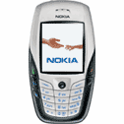
Planet-Lab Node
(planetlab2.enel.ucalgary.ca:1099)
JADE-LEAP Server
Hospital Manager Agents
DB1
DB2
Ag.1
Ag.2
Internet
Ag.3
Linux Station
Windows Station
Ambulance Manager Agent
GPS
Fortuna GPSmart
Nokia 6600
Bluetooth
GPRS
Figure 11: Deployment Diagram

2.3.1 Deployment Diagram
The developed application was deployed successfully using the environment showed in Fig. 11.
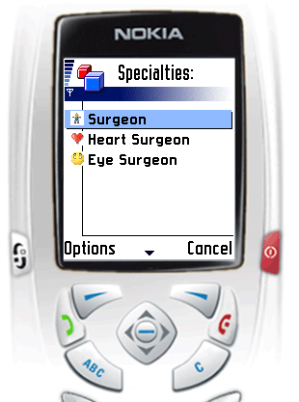
The JADE-LEAP server was deployed in a PlanetLab node. Planetlab (www.planet-lab.org) is an open platform for developing, deploying, and accessing planetary-scale services. Currently it has more than 520 nodes distributed globally over 245 sites. By installing our server we allow agents running in different locations to access the network at the closest server from their location. The hospital manager agent number 1 runs on a Windows 2000 machine and provides information from one simulated hospital (Hospital_A) to the agent platform. The hospital manager agent number 2 runs on a Redhat Linux machine providing the same type of information as agent 1 but from a different hospital.
Figure 12: Ambulance Driver Menu
This simulated hospital’s (Hospital_B) internal system may be different than the one from Hospital_A. This ensures that our framework can be distributed over several operating systems and application systems seamlessly.
Agents 1 and 2 connect to the JADE-LEAP server over the internet. The ambulance manager agent (agent 3) runs on a Nokia 6600 cell phone. It connects to the JADE-LEAP server by a wireless connection, using a GSM network and the GRPS protocol as seen in Fig. 10. The connection between the Nokia 6600 and the GPS receiver is done using the Bluetooth protocol. In order to test this connection using a MIDP application, we used the application BlueLet from www.benhui.net. This application provides a basic framework to establish Bluetooth connections and helped us prove that the information from the GPS receiver could be retrieved.

2.4 Graphic User Interface
Fig. 12 and 13 show how an ambulance driver will interact with the application running on the cell phone. After assessing the nature of the emergency and having decided which kind of medical specialist the patient may require, the driver simply selects from the graphical menu the desired specialist - as seen in Fig. 12.
After that the application will contact all the hospitals that are registered in the DF and find the closest available specialist from the ambulance current position. The application will indicate to the driver how to act without any other user input required. The results of the search are displayed as shown in Fig. 13.

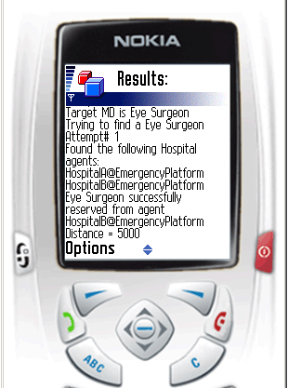
Conclusions and Future Work
Figure 13: Search Results
The goal of this work was to develop a pervasive application using a multi-agent framework capable of being deployed over a wireless network and to propose a mechanism for accessing information contained in a heterogeneous environment. The following objectives were successfully achieved:
• The application can be executed over different operating systems seamlessly. As seen in Fig. 10 the application was deployed successfully over Redhat Linux, Windows 2000, PlanetLab Linux and a Nokia 6600 cell phone.
• The application successfully accessed the GPS information from the GPS receiver using third-party software.
• The application successfully selected the closest resource based on the user selection of the needed specialist and the distance from the user’s current location to the simulated hospitals. This decision making process was using information gathered from the systems at the hospitals, the user input and location information.
JADE with the LEAP extension is a suitable multi-agent framework for the creation of J2ME applications deployable over wireless networks in hardware constrained devices such as cell phones and PDAs. We also could access information in pervasive devices using the Bluetooth protocol and made this interaction between devices transparent to the user of the application. The emergency management ontology developed for the application allows sharing information between different applications in a standardized way and the use of FIPA protocols allows the communication between these systems.
This work also demonstrates that there are enough helper applications on the market that allow creating a multi-agent system with graphical interfaces and semi-automated code generation. The following list shows functionality that we did not implement but would be desirable for a real emergency environment:
• Best path to the hospital: The application should direct the ambulance driver to the hospital using the fastest route in order to reach the hospital as soon as possible. This requires the creation of search algorithms that can be implemented in the system as a task being performed by another agent.
• Accessing other systems in order to obtain information that is relevant to the emergency at hand: There are more sources of information that can provide critical data in case of an emergency. These sources can be:
o City Hall: for blueprints of buildings
o Mapping system: there are systems available that provide information about city streets mapping.
o Fire Department: by including interaction with the fire department the system could dispatch or request the presence of fire-fighters in an emergency location.
o Police Department: the information provided by the police could help detecting emergencies and relocating resources in order to manage that situation. Also to re-direct traffic if required at the scene of the accident, if applicable.
o Resource allocation subsystem: The subsystem could oversee the status of a region and allocate resources to the emergencies happening in the area of its control.
Finally, further integration between pervasive devices and a multi-agent system created using the proposed framework will allow the system to provide more functionality to the end user. This integration is not only desirable for the emergency systems domain, but for any application on other domains that a developer may create.

References
- Weiser, M. Scheduling for Reduced CPU Energy. in 1st USENIX Symposium on Operating Systems and Implementation. 1994. Monterey, CA
- Nelson, A.D.B.a.B.J., Implementing Remote Procedure Calls. ACM transactions on Computer Systems, 1984. 2(1).
- Satyanarayanan, M., Pervasive Computing: Vision and Challenges. IEEE Personal Communication, 2001: p. 10-17.
- D. Saha, A.M., Networking Infrastructure for Pervasive Computing: Enabling Technologies and Systems. 2002, Kluwer Academic.
- Lebeck, A.R. Power Aware Page Allocation. in 9th International Conference on Architectural Support for Programming Languages and Operating Systems. 2000.
- Wooldridge, M. and N.R. Jennings, Intelligent Agents: Theory and Practice. Knowledge Engineering Review, 1995. 10(2): p. 115-152.
- Maes, P., "General Tutorial on Software Agents at the Conference on Human Factors in Computer Systems" Atlanta, Georgia, USA. Available at http://pattie.www.media.mit.edu/people/pattie/CHI97/, 1997.
- JADE – Java Agent Development Framework. http://jade.tilab.com/
- LEAP – Lightweight Extensible Agent Platform. http://leap.crm-paris.com/
- FIPA – The Foundation for Intelligent and Physical Agents. http://www.fipa.org
- J2ME – Java 2 – Micro Edition. http://java.sun.com/j2me/index.jsp
- Nokia Mobiles Phones for the USA. http://www.nokiausa.com/phones/
- Motorola Cell Phones. http://www.motorola.com
- BlackBerry. http://www.blackberry.com
- Mihaela Ulieru, Maja Hadzic, Elizabeth Chang, “ Soft Computing Agents for e-Health Applied to the Research and Control of Unknown Diseases”, http://www.enel.ucalgary.ca/People/Ulieru/
- MIT House_n Projects. http://architecture.mit.edu/house_n/projects.html
- Canada Intelligent Transportation System. http://www.its-sti.gc.ca/en/what_is_its.htm

