Integrated Soft Computing Methodology for Diagnosis and Prediction with Application to Glaucoma Risk Evaluation

Mihaela Ulieru* and Gerhardt Pogrzeba**
*Faculty of Engineering
The University of Calgary
2500 University Dr. NW, Calgary, Alberta T2N 1N4 CANADA
Tel. (403) 220-8616; Fax: (403) 282-6855; e-mail: ulieru@ucalgary.ca
http://isg.enme.ucalgary.ca/People/Ulieru/Default.htm
**President and CEO
TRANSFERTECH GmbH
Braunschweig, Germany
info@transfertech.de, www.transfertech.de

ABSTRACT
A methodology for diagnosis and prediction, which integrates several soft computing techniques, is introduced. Already implemented in the medical context of glaucoma diagnosis using several software packages developed by Transfertech GmbH Germany, the methodology is easily extendable to other medical as well as technical risk evaluation and damage progression applications.

KEY WORDS: Hybrid Systems, Fuzzy Diagnosis, Evolutionary Optimization, Glaucoma, Risk Evaluation, Damage Progression Monitoring/Prediction.

1. Introduction

As a medical activity, diagnosis aims to determine if a patient suffers of a specific disease, and if the answer is yes, to provide a specific treatment [1]. In the particular case of glaucoma the main challenge for the ophthalmologist is not as much the diagnosis itself but rather the evaluation of the risk for its occurrence and the prediction of disease progression to establish a suitable follow up and treatment accordingly.
Glaucoma is a progressive eye disease that damages the optic nerve, usually associated with increased intraocular pressure (IOP). If left untreated, it can lead to blindness, being a leading cause of blindness. Glaucoma is affecting some 67 million people all over the world. In Canada there are about 200,000 glaucoma cases [3]. For more details regarding glaucoma please see: [4], [5] and [6].
In about 70% of the cases the diagnosis of glaucoma is pretty evident for ophthalmologists. There are some cases however (at least one a day) where a specialist doesn’t know if the patient has glaucoma or not. For these special cases (that make an approximate 5% of patients), support from an ‘expert machine’ in assessing risk and disease progression is essential in determining the right time for a follow up check as well as ‘in-between’ treatment [4].

In response to this need we have developed an integrated diagnosis and prediction methodology that uses several soft computing techniques, as it will be presented in the next section.

2. THE DIAGNOSTIC METHODOLOGY
AT A GLANCE

The methodology has been designed around the software suite developed by Transfertech GmbH Germany [2], Fig. 1, by integrating several of their packages.
The methodology aims on one side to emulate the assessment done by the expert physician, while at the same time it collects data relevant for predicting the disease progression. To cover both these goals two fuzzy inference engines are run in parallel (Diagnosis Engine and respectively Prediction Engine in Fig. 1). The Diagnosis Engine embeds expert knowledge (expressed as fuzzy if-then rules which are designed as presented in the next section) while the Prediction Engine is developed in a three step process presented in Section 4.
The double function of the ‘expert machine’ is ensured by first running the diagnosis engine which emulates a standard diagnosis procedure made by the expert physician, and then running through the prediction engine the assessment obtained using the diagnosis engine together with the prescribed treatment and follow-up time interval determined by the medical doctor.
A standard investigation procedure [4] consists of several ophthalmic measurements done with various test machines measuring parameters relevant for the disease assessment, as presented in Fig. 2. The test data collected for each patient is stored in a database (on the same machine as the fuzzy engines). Each new set of test parameters collected from the various ophthalmic devices, Fig. 2) is run through the diagnosis engine, Fig. 1, (eventually together with the medical expert opinion and subjective evaluations) and as result the ‘disease assessment’ of the patent status is obtained.
Machine Parameters
(Measured)
Diagnosis
Engine
Disease Assessment

Prediction
Engine

Treatment
Follow-up Time
Doctor’s
Decision
Doctor’s
Decision

Machine Parameters
Disease Assessment
Treatment
Time
Prediction
Prediction
Data Base
Diagnosis
Prediction
Fig. 2: Standard diagnosis procedure at one ophthalmic clinic
Fig. 1: The risk evaluation and disease progression methodology

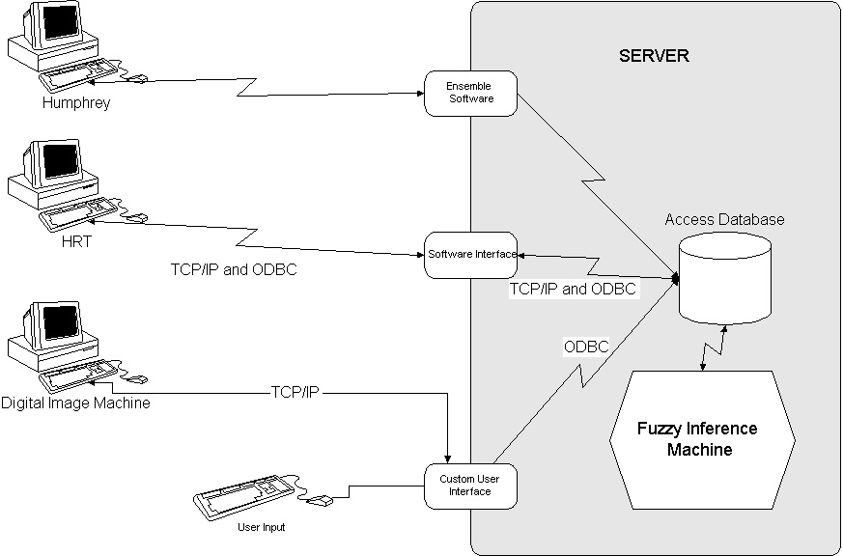
For the prediction stage a continuous evaluation of the prediction rule base is done by assessing the accuracy of the previous prediction comparatively to the ‘disease assessment’ obtained at the follow-up (determined by running the prediction engine at the previous visit.) The three steps of this process will be detailed in Section 4. In the next Section we will underline the major challenges faced while designing the medical diagnosis engine.

3. DESIGN OF THE DIAGNOSIS ENGINE
FOR DISEASE ASSESMENT

The diagnosis of glaucoma involves not only the classical group of conditions mentioned in every book associated to this disease, but it also comprises the analysis of a myriad of risk factors, each of them related to the diagnosis with different degrees. The diagnosis rule base has been developed following an incremental development process, Fig. 3 [7]. Following this process, a set of Fuzzy IF-THEN Rules was developed, as follows.
We used 21 glaucoma risk factors as variable inputs for the diagnosis engine: Age, Myopia, Last eye examination, Steroids using, Diabetes, Family history (parents or brothers and sisters with glaucoma), IOP, Diurnal Fluctuations of IOP, Race, Abnormal visual field tests, Hypertension, Weight, History of caffeine intake, History of smoking, Hands/Feet Temp., History of migraine/Reynaud’s, History of eye injury, History of uveitis, History of retinal detachments, History of pigment dispersion, History of pseudoexfoliation.
Fig. 3: Diagnosis engine design via the incremental development process

The output of the diagnostic engine evaluates the ‘disease assessment’ via the fuzzy variable Risk with three terms: Low, Moderate and High. The risk factors are mapped to the disease assessment via fuzzy if-then rules such as:
IF Myopia is High and IOP is High THEN Risk is High
IF Hands/Feet Temp is Cold and Hypertension is Present THEN Risk is Moderate
IF Myopia is High and Age is Old THEN Risk is High
IF Hypertension is Present and Diabetes is High THEN Risk is Moderate
IF Weight is Obese and History of caffeine intalce is Large and History of smoking is Large and History of retinal detachments is Present THEN Risk is Moderate

The first step within this incremental process (Fig. 3) was to define the requirements of the system to be developed. After analyzing these requirements, top-level specifications have been defined and an incremental development plan designed.
In the first increment a minimal group of Fuzzy IF-THEN Rules has been created. This ‘basic’ set of rules has been used to create a foundation for selecting relevant learning data for improving the prediction engine, as it will be explained in the next Section. Different risk factors and data (e.g. collected from patient files) have been used to add new rules in each successive increment. Each increment will contain all previously developed rules plus some new ones determined to be relevant by the medical expert.
Requirements
Top-level specifications
Incremental development plan
Iteration 1:
First set of rules
Visits to dr.’s office
Ophthalmologist feedback
Iteration 2:
Second set of rules
Visits to dr.’s office
Dr.’s feedback
Neuro – fuzzy System
Complete set of fuzzy rules
Iteration n

4. AN EVOLUTIONARY LEARNING
STRATEGY FOR TUNING THE
PREDICTION ENGINE

This step assumes that a database with sufficient patient information is already available to be used in the three step learning process. The design of the database itself was a challenging process, mainly because very few patient data was available in electronic form. We had to input most of the data from the patient files that were handwritten by the medical specialist. The database was organized by storing the measured parameters, the ‘disease assessment’ (made by the medical doctor at the investigation time during that particular patient visit) as well as the treatment and time interval decided by the medical expert for scheduling the next visit (patient’s follow-up date) as well as the result of running the prediction engine. (For details regarding the database design see [7].)
During the next visit the evaluated ‘disease assessment’ is compared with the prediction made by the system at the previous visit and depending on the result, that particular dataset is ‘marked’ in the database as either ‘learning relevant’ (if the predicted status was similar to the doctor evaluation), or as ‘learning irrelevant’ otherwise.
Fig. 4: Patient Data

The marking of relevant data is made by using Clustering Analysis Manager (CAM) in combination with the Fuzzy Control Manager (FCM) developed by Transfertech, GmbH Germany [2], Fig. 4. If the ‘basic’ rule set (mentioned in Section 3) is not available for the diagnosis engine (which was our case in the beginning when all the information available was handwritten in the patient files) an initial step is required to create this basic fuzzy rule base.

Fig. 4: Three steps development

For this (Step 1 in Fig. 4), first an initial database needs to be created in electronic form from patient files, containing information as previously explained. This data will be exported to the CAM which will create based on it an initial fuzzy rule base (CAM-Fuzzy Project). Based on this initial fuzzy rule base a ‘marking’ rule base will be designed in the generic form:

IF {conditions} THEN {marking value}

,where the {conditions} part contains the data fields to be evaluated for learning at Step 2 of the procedure in Fig. 4.
Once this ‘marking rule base’ is determined, the Fuzzy Control Manager can be run to determine the marking values for the database (Step 2 in Fig. 4).

Now the database is prepared for the learning stage, which involves Transfertech’s evolutionary optimizer (EVO), as illustrated in Step 3 of Fig. 4. The data marked as ‘learning relevant’ in the database will be processed by the EVO as follows:
- Set the optimization parameters (fitness function, etc.)
- Load the initial data (that is the prediction rule base in Fig. 1 – named ‘old fuzzy engine’ in Fig. 4, Step 3) and the learning data.
- The EVO will process this initial data and deliver a new fuzzy rule base containing the updated rules for the prediction (Updated Fuzzy Engine in Fig. 4).

NOTE. An alternative to the use of the CAM to mark the learning data from the data base is the use of the Learning Data Generator (LDG) provided by Transfertech. This tool reads the input-output data set from a previous run of the diagnosis engine and provides a file containing the previous inputs together with the ‘expected output’ of the diagnosis engine. This would enable complete automation of the diagnosis procedure as there will be no more need for the ‘doctor’s decision’ step in Fig. 1. However the disadvantage consists in this case in the requirement for more optimization rules to be ‘crunched’ by the EVO. The main advantage of using the LDG consists in that it enables evaluation of the accuracy of the prediction, giving very useful feedback for learning. We are in the process of experimenting with this tool.

6. WEB-CENTRIC EXTENSION OF THE
SYSTEM

As it results from Fig. 2 all the data involved in the diagnosis and prediction process is centralized in a database located on a server together with the fuzzy inference (diagnosis and respectively prediction) machines. This leads naturally to the idea of extending the learning capability of the diagnostic system by enabling data from several clinics to contribute to the knowledge refinement process, Fig. 5 [8].
The prediction system to be updated periodically using the EVO as explained in the previous Section will be placed on a central server together with the central database (storing patient data from all the clinics involved in the diagnosis network, [7]). The central database will be updated periodically from each clinic. A copy of the diagnosis and prediction engines will function in each clinic and will be updated after the learning process is done on the central ‘master’ copy. This will be done at regular intervals, ranging between one week and one month, depending on the amount of new learning data marked from the patient examinations submitted by each clinic. To connect the local engines from each clinic to the ‘master’ engines located on the central server a secure and reliable connection has to be established, as patient data is sensitive. Or goal is to make this system available on the international health care arena, and therefore several standards have to be investigated and reconciled. We are currently working on the development of a holarchy, [9] that would enable the access of the diagnosis and prediction system not only from the clinics but as well by nomadic patients independent of their location, eventually via latest wireless technology.

7. AcknowledgementS

This work is funded by the Natural Science and Engineering Research Council of Canada (NSERC) under Collaborative Health Research Project Grant. The contribution of Dr. Andrew C. S. Crichton, Department of Surgery, Faculty of Medicine at the University of Calgary, to the development of the diagnostic and prediction knowledge bases is highly praised. The work of Dr. Nicolae Varachiu, associate research, and of the MSc students Cynthia Karanicolas, Dong Liu and Adam Geras, all at the University of Calgary, is gratefully acknowledged.

References

[1] Ulieru, M., Fuzzy Logic in Diagnosis: Possibilistic networks, Invited Chapter in Fuzzy Logic (J. Baldwin, Ed.), John Wiley and Sons, ISBN 0471962813, 1996.

[2] www.transfertech.de

[3] G. E. Trope, Glaucoma: A Patient’s Guide to the
Disease (Univ. of Toronto Pr., 2001)

[4] M. Ulieru, O. Cuzzani, S. H. Rubin, M. G. Ceruti,
Application of Soft Computing Methods to the
Diagnosis and Prediction of Glaucoma, Proc. O
the 2000 IEEE International Conference on
System, Man, and Cybernetics, SMC 2000,
“Cyubernetics Evolving to Systems, Humans,
Organizations, and their Complex
Interactions”, Nashville, TN, USA, Oct. 8-11.

[5] N. T. Choplin, D. C. Lundy, A. D. Dreher, Differentiating patients with glaucoma from glaucoma suspects and normal subjects by nerve fiber layer assessment with scanning laser polarimetry, American J. of Ophthalmology, vol. 105, no 11, Nov. 1998
[6] A. C. S. Crichton, J. A. McWhae, Ultrasound biomicroscopy: applications in glaucoma, Ophthalmic Practice Journal, vol. 16, no. 4, Aug. 1998.

[7] Varachiu, N., Karanicolas, C. and Ulieru, M., A computational Intelligence Approach to Medical Knowledge Acquisition with Application to Glaucoma, First IEEE International Conference on Cognitive Informatics, August 19/20, The University of Calgary, Alberta, Canada.

[8] Ulieru, M., Web-Centric Diagnosis and Prediction System for Global Manufacturing, IFSA-NAFIPS Joint Conference on Fuzzy Systems 2001, Vancouver, Canada, July 24-27, 2001, pp 310-315

[9] Geras, A., Ulieru, M, A Medical Holarchy for e-Health Applications, First International Workshop on Challenges in Open-System Environments, Autonomous Agents and Multi-Agent Systems Conference AAMAS 2002, Bologna, Italy, July 15-19, 2002.

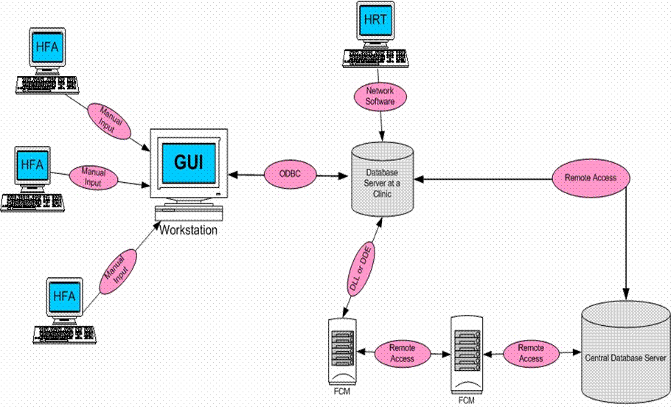
Fig. 5: The Web-Centric Solution for the Glaucoma Diagnosis and Prediction System

Due to nondisclosure agreements with Transfertech we cannot give more details regarding this procedure

